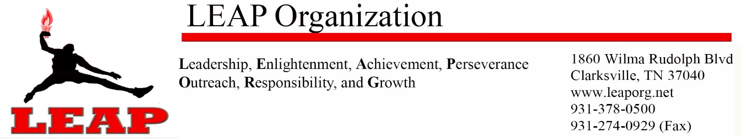
FOR IMMEDIATE RELEASE November 7, 2016
LEAP Scholarship Essay Contest
Clarksville, TN – The LEAP Annual 7 Points Scholarship Essay Contest is open to CMCSS and Fort Campbell high school seniors. Each year, the theme highlights one of our 7 principles of Leadership, Enlightenment, Achievement, Perseverance, Outreach, Responsibility, and Growth.
The LEAP Organization recognizes the importance of encouraging youth to be productive and responsible citizens, and is honored to provide resources to assist youth in their quest to pursue higher learning opportunities.
For the past 7 years, LEAP has awarded scholarships to well deserving students. This year we will be awarding one $1,000 scholarship to first place and one $500 scholarship to second place.
This year’s theme is Responsibility and essays must address the following questions. Do you consider yourself to be a responsible person? Why? In what ways? What responsibilities do you believe you personally have for: 1) yourself, 2) your family, 3) your community, 4) the world? What does being responsible have to do with the quality of your character? Describe something you've done that was really irresponsible. How did you feel afterward? What did you learn from it? Describe what this society might be like if nobody was accountable for their actions, if nobody kept their commitments. What are the benefits of being a responsible person? How do you benefit from the responsibility of others?
To be eligible for consideration, essays must meet the following guidelines:
- Essay must address the 2016 – 7 Points Theme
- Essay must be 350 – 750 words, typed and double spaced. Must be a senior to apply
- Include Name, School, and Contact # in top right corner of each page.
- Deadline to submit essay is January 31, 2016.
- Entries may be submitted either via email to info@leaporg.net, fax to 931.274.0929, or mail/deliver to 1860 Wilma Rudolph Blvd Clarksville, TN 37040.
- Winners will be required to read their essays at our annual Dining with the Stars Gala on March 4, 2017 at the Riverview Inn between 6 and 9 pm.

For additional info call 931.614.0440 or visit www.leaporg.net/scholarships

###

